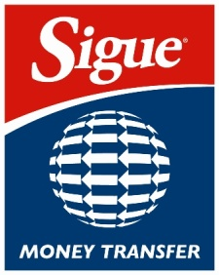

Sigue Money Transfer Partner Network API Access Form

Contact Information
Company Name & Address | Partner Company Name & Address
SIGUE Corporation
13291 Ralston Ave Sylmar, CA 91342
Company Contact & Telephone Number | Company Contact & Telephone Number
Ignacio Ramirez
+1 (866)590 4556 ext 7900
Email Address | Email Address
Ignacio.ramirez@sigue.com
IT Support (Help Desk) | Technician Contact & Telephone Number
+1 (866)590 4556 ext 7900
Email Address | Email Address
helpdesk@sigue.com
Access
HTTPS Service Production – https://api.cmtpartnernetwork.com
HTTPS Service TEST/DEV – https://apitest.cmtpartnernetwork.com

Partner Host Information (***Production and Test Server IP should not same)
Production Server IP address(s) *** | Subnet Mask
Test/Dev Server IP address(s)*** | Subnet Mask

Partner Protocol Information
Source IP &  Subnet Mask | Destination IP &  Subnet Mask | Transport Protocol | Destination Port | Application Name | Initiator  (or Bi-directional)
 | https://api.cmtpartnernetwork.com | TCP/445 | 443 | API
Example:  1.1.1.0/32 | Example:  2.2.2.0/32 | Example:  TCP | Example:  80 | Example:  Website | Example:  Source

Source IP Address: The complete IP address or IP network and mask.
Destination IP Address: The complete IP address or IP network and mask.
Transport Protocol: The desired protocol used by the application.
Destination Port: The port from which the application “listens.”
Application Name: The name of the Application that will be “listening” on the Destination Port.
Initiator (Bi-directional): The machine that will connect to the Destination Port to initiate the session. Please indicate if both machines will need to initiate sessions.

